Sunday Matins
Abridged for Parish Use

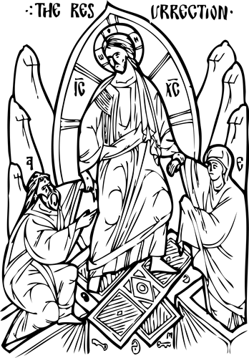

Updated 8 July 2023
Usual Beginning
Priest:  Deacon: Master, give the blessing.  Priest: + Blessed be our God, always, now and for ever and ever. | With no priest:  Deacon or Reader: + Through the prayers of our holy fathers, Lord Jesus Christ, our God, have mercy on us.
  People: Amín’. | Amen.
  People: Amín’. | Amen.
R. Amin’.
Dcn/Rdr: Glory be to You, our God, * glory be to You.
People: Heavenly King, Advocate, Spirit of Truth, * Who are everywhere present and fill all things, * Treasury of Blessings, Bestower of Life, * come, and dwell within us; * cleanse us of all that defiles us, * and, O Good One, save our souls.
Dcn/Rdr: + Sviatýi Bózhe, sviatýi krípkyi, sviatýi bezsmértnyi, pomýlui nas.  People: + Sviatýi Bózhe, sviatýi krípkyi, sviatýi bezsmértnyi, pomýlui nas.  Dcn/Rdr: + Sviatýi Bózhe, sviatýi krípkyi, sviatýi bezsmértnyi, pomýlui nas.  People: + Sláva Otsíu, i Sýnu, i Sviatómu Dúkhovi:  Dcn/Rdr: i nýni i povsiakchás, i na víky víchni. Amín’. | Dcn/Rdr: + Holy God, Holy and Mighty, Holy and Immortal, have mercy on us.  People: + Holy God, Holy and Mighty, Holy and Immortal, have mercy on us.  Dcn/Rdr: + Holy God, Holy and Mighty, Holy and Immortal, have mercy on us.  People: + Glory be to the Father, and to the Son, and to the Holy Spirit:  Dcn/Rdr: now and for ever and ever. Amen.
People: Trinity most holy, have mercy on us. * Cleanse us of our sins, O Lord; * pardon our transgressions, O Master; * look upon our weaknesses and heal them, O Holy One; * for the sake of Your name.
Dcn/Rdr: Hóspody, pomýlui. Hóspody, pomýlui. Hóspody, pomýlui.  People: + Sláva Otsíu, i Sýnu, i Sviatómu Dúkhovi:  Dcn/Rdr: i nýni i povsiakchás, i na víky víchni. Amín’. | Dcn/Rdr: Lord, have mercy. Lord, have mercy. Lord, have mercy.  People: + Glory be to the Father and to the Son and to the Holy Spirit:  Dcn/Rdr: now and for ever and ever. Amen.
People: Our Father, * Who art in heaven, * hallowed be Thy Name. * Thy Kingdom come. Thy will be done * on earth as it is in heaven. * Give us this day our daily bread; * and forgive us our trespasses * as we forgive those who trespass against us. * And lead us not into temptation, * but deliver us from evil.
With priest:  Priest: For the kingdom, the power, and the glory are Yours, + Father, Son, and Holy Spirit, now and for ever and ever. | With no priest:  Dcn/Rdr: + Through the prayers of our holy Fathers, Lord Jesus Christ, Our God, Have mercy on us.
  People: Amín’.  Dcn/Pr: Hóspody, pomýlui. (6)  People: Hóspody, pomýlui. (6)  Dcn/Pr: + Sláva Otsíu, i Sýnu, i Sviatómu Dúkhovi:  People: i nýni i povsiakchás, i na víky víchni. Amín’. | Amen.  Dcn/Pr: Lord, have mercy. (6)  People: Lord, have mercy. (6)  Dcn/Pr: + Glory be to the Father, and to the Son, and to the Holy Spirit:  People: now and for ever and ever. Amen.
  People: Amín’.  Dcn/Rdr: Hóspody, pomýlui. (6)  People: Hóspody, pomýlui. (6)  Dcn/Rdr: + Sláva Otsíu, i Sýnu, i Sviatómu Dúkhovi:  People: i nýni i povsiakchás, i na víky víchni. Amín’. | Amen.  Dcn/Rdr: Lord, have mercy. (6)  People: Lord, have mercy. (6)  Dcn/Rdr: + Glory be to the Father, and to the Son, and to the Holy Spirit:  People: now and for ever and ever. Amen.
Dcn/Rdr: + Come, let us bow in worship before the King, our God.
People: + Come, let us bow in worship before Christ, the King, our God.
Dcn/Rdr: + Come, let us bow in worship and fall down before the very Lord, Jesus Christ, our King and God.

Psalm 50
Have mercy on me, O God, in the greatness of Your compassion; * according to the multitude of Your mercies blot out my offense.
Wash me thoroughly from my iniquity, * and cleanse me from my sin.
1 For I acknowledge my iniquity, * and my sin is always before me.
2 Against You alone have I sinned * and done what is evil in Your sight,
1 That You may be justified when You speak * and win when You are judged.
2 Behold, in wickedness I was conceived * and in sin my mother bore me.
1 For see, You have loved truth; * You have shown me the hidden and secret things of your wisdom.
2 Sprinkle me with hyssop and I shall be clean. * Wash me and I shall be whiter than snow.
1 Make me hear joy and gladness; * the bones that were crushed shall rejoice.
2 Turn away Your face from my sins, * and blot out all my iniquities.
1 Create in me a pure heart, O God, * and renew a right spirit within me.
2 Cast me not from Your presence, * nor deprive me of Your Holy Spirit.
1 Give me again the joy of Your salvation, * and sustain me with Your sovereign Spirit.
2 I will teach transgressors Your ways, * and sinners will return to You.
1 Deliver me from blood guilt, O God, the God of my salvation, * and my tongue shall ring out Your justice.
2 Lord, You will open my lips, * and my mouth shall declare Your praise.
1 For if You had wanted sacrifice, I would have given it; * You will not take pleasure in burnt offerings.
2 A sacrifice to God is a contrite spirit. * A humbled and contrite heart God will not spurn.
1 Deal favorably, O Lord, with Sion in Your good pleasure * and let the walls of Jerusalem be rebuilt.
2 Then You will be well-pleased with a sacrifice of justice, oblations and holocausts; * then they will lay calves upon Your altar.
God the Lord
All: (Tone 4, Prokeimenon)
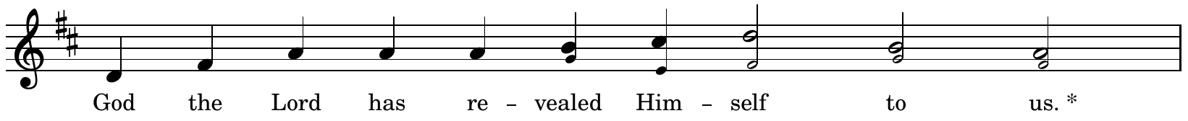
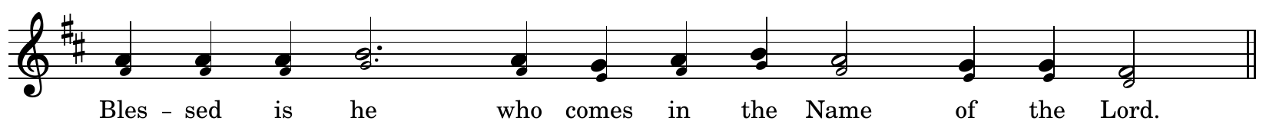
Dcn/Rdr: Give thanks to the Lord, for He is good; * for His love endures forever.
All: God the Lord…
Dcn/Rdr: They encircled me, compassed me about; * in the Lord’s name I crushed them.
All: God the Lord…
Dcn/Rdr: I shall not die, I shall live * and recount the deeds of the Lord.
All: God the Lord…
Dcn/Rdr: The stone which the builders rejected has become the cornerstone. * This is the work of the Lord, a marvel in our eyes.
All: God the Lord…

Resurrectional Troparion
The Resurrectional Troparion of the Sunday is sung.

Hosts of Angels
All:
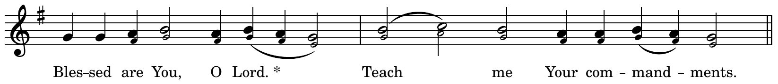
Choir: The hosts of angels were amazed and dazzled * when they beheld You, O Savior, among the dead, * destroying the power of Death, * raising up Adam with You ** and releasing * all the souls from Hades.
All: Blessed are You, O Lord, * teach me Your commandments.
Choir: The radiant angel standing by the grave * cried out to the ointment-bearing women: * Why do you lament and mingle your tears with the spices? * Look upon the grave and rejoice, ** for the Savior * is risen from the dead.
All: Blessed are You, O Lord, * teach me Your commandments.
Choir: The ointment-bearing women * hastened very early to Your grave. * But the angel stood by them and said: * The time for lamenting is no more. ** Do not cry, * but go and announce the Resurrection to the disciples.
All: Blessed are You, O Lord, * teach me Your commandments.
Choir: O Savior, the ointment-bearing women * came to Your grave with ointments, * and they heard the angel say to them: * Why are you seeking the Living One among the dead? ** Indeed, He is God. * He is risen from the dead.
All:
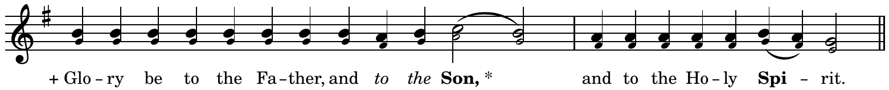
Choir: We worship the + Father * and His Son and His Holy Spirit, * the Holy Trinity, One in essence, * and we cry out with the seraphim: ** Holy, holy, * holy are You, O Lord.

All:
Choir: O Virgin, you bore the Giver of Life. * Who redeemed Adam from his sin * and granted joy to Eve * instead of sadness. * For He Who is both God and Man * was incarnate of you, ** and He has restored life * to those who had strayed away from it.
All:
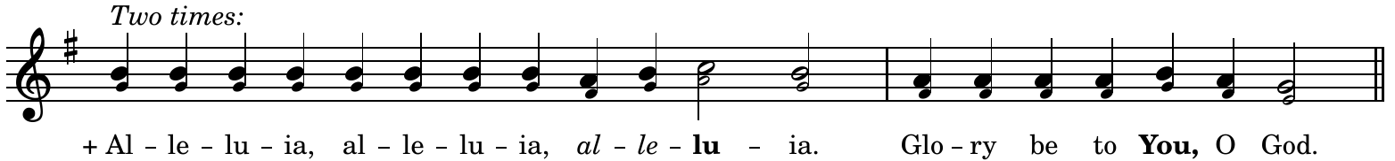
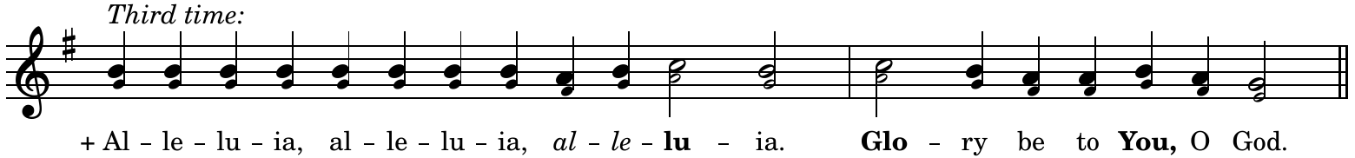

Prokeimenon
With priest:  Deacon: Wisdom!  Priest: Peace be with all.  Deacon: Wisdom! Let us be attentive! | With no priest:  Dcn/Rdr: + Through the prayers of our holy fathers, Lord Jesus Christ, our God, have mercy on us.
  People: Amín’. | Amen.

The prokeimenon of the Sunday is sung.

[Deacon or Priest: Let us pray to the Lord!
People: Hóspody, pomýlui. | Lord, have mercy. ]

With priest:  Priest: For You, our God, are holy, and we give glory to You, + Father, Son, and Holy Spirit, now and for ever and ever. | With no priest:  Dcn/Rdr: + Through the prayers of our holy fathers, Lord Jesus Christ, our God, have mercy on us.
  People: Amín’. | Amen.
  People: Amín’. | Amen.

Prayers before the Gospel
All: (Tone 4, Prokeimenon)
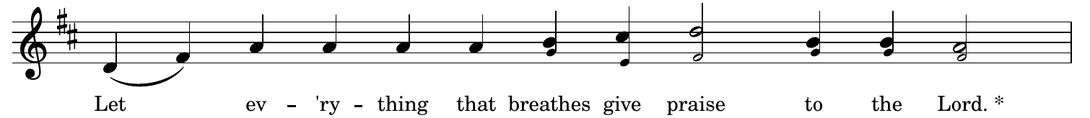
Dcn/Rdr: Praise God in His holy place, * praise Him in His mighty heavens.
All: Let everything that breathes…

[Deacon: That we may be deemed worthy of hearing the holy Gospel, let us pray to the Lord, our God.
People: Hóspody, pomýlui. (3) | Lord, have mercy. (3) ]

The Reading of the Matins Gospel
With priest:  Priest: Wisdom!  Stand aright!  Let us listen to the holy Gospel.  Peace + be with all.  People:  Deacon: A reading from the holy Gospel according to (name).  People:  Priest: Let us be attentive!  Priest reads the appointed Resurrection Gospel.  People: | With no priest:  Deacon: A reading from the holy Gospel according to (name).  People:  Deacon reads the appointed Resurrection Gospel.  People: | With no priest or deacon:  (The Gospel is NOT CHANTED, but read in a normal voice facing East.)  Reader: A reading from the Holy Gospel according to (name).  Reader reads the appointed Resurrection Gospel in a normal voice.
  I dúkhovi tvoyému. | And with your spirit.
  + Sláva Tobí, Hóspody, sláva Tobí. | + Glory be to You, O Lord, glory be to You.
  + Sláva Tobí, Hóspody, sláva Tobí. | + Glory be to You, O Lord, glory be to You.
  + Sláva Tobí, Hóspody, sláva Tobí. | + Glory be to You, O Lord, glory be to You.
  + Sláva Tobí, Hóspody, sláva Tobí. | + Glory be to You, O Lord, glory be to You.

Hymn of the Resurrection
(Tone 6, samohlasen)
All: Having beheld the Resurrection of Christ, * let us + adore the holy Lord Jesus, Who alone is sinless. * We + bow to your cross, O Christ, * and we praise and glorify Your holy Resurrection. * You are our God and besides You we recognize no other, * and we invoke Your name. * Come, all you faithful, and let us + bow to the holy Resurrection of Christ, * since through the Cross joy has come to all the world. * Ever praising the Lord, * let us extol His Resurrection, * since He, having endured the Crucifixion, * has destroyed death by His death.

The Praises
(Tone 6, samohlasen)
Let everything that lives and that breathes * give praise to the Lord. * Praise the Lord from the heavens; * praise Him in the heights. * To You is due a hymn, O God.
Praise Him, all His angels. * Praise Him, all His hosts. * To You is due a hymn, O God.

Great Doxology
[Deacon or Priest: Glory to You Who have shown us the light!]
All:
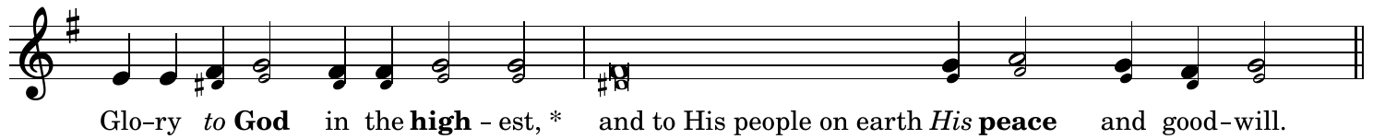
Lord God, Heavenly King, Almighty God and Father, * with the Lord Jesus Christ, only Son of the Father, and the Holy Spirit.
We praise You, we bless You, we worship You, * we glorify You, we thank You for Your great glory.
Lord God, Lamb of God, Son of the Father, * You take away the sin of the world, have mercy on us.
You take away the sins of the world, * hear our prayer.
You are seated at the right hand of the Father, * have mercy on us.
For You alone are holy, You alone are the Lord, Jesus Christ, * for the glory of God the Father. Amen.
I will bless You day after day, * and praise Your name forever.
Count us worthy, O Lord * of passing this day without sin.
Blessed are You, O Lord, God of our fathers, * and praised and glorified is Your name forever. Amen.
Let your mercy, O Lord, be upon us * because we have set our hope in you.
+ Blessed are You, O Lord, * teach me Your commandments.
+ Blessed are You, O Master, * make me understand Your commandments.
+ Blessed are You, O Holy One, * enlighten me with Your commandments.
O Lord, You have been our refuge * from one generation to the next.
I said: Lord, have mercy on me, * heal my soul, for I have sinned against You.
O Lord, I have fled to You, teach me to do Your will, * for You, O Lord, are my God.
In You is the source of life * and in Your light we see light.
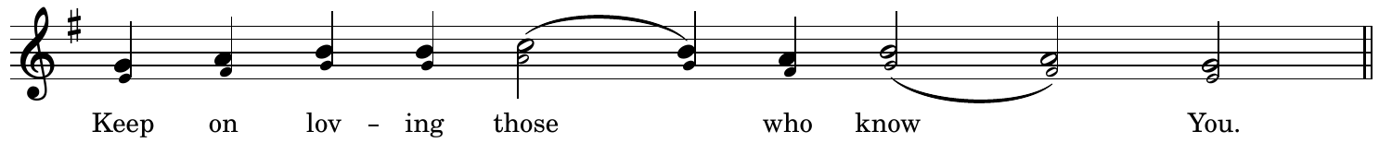
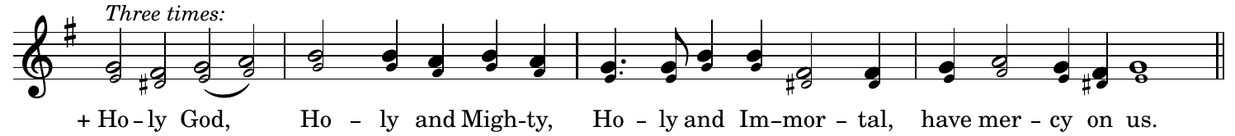
+ Glory be to Father, and to the Son, and to the Holy Spirit, * now and for ever and ever. Amen.
Holy and Immortal, have mercy on us.
+ Holy God, Holy and Mighty, Holy and Immortal, have mercy on us.

Troparion After the Great Doxology
When the Tone of the Week is 1, 3, 5, or 7:
(Tone 2, Troparion)
Let us sing to Him Who is risen from the tomb, * the Author of Life Who has crushed Death by His death * and bestowed on us victory and great mercy.

When the Tone of the Week is 2, 4, 6, or 8:
(Tone 2, Troparion)
You broke the curse of Death and thus delivered us from the snares of the Evil One. * Then You appeared to Your Apostles and sent them forth to preach, * and through them You have bestowed Your peace upon all the world, * for You alone are rich in mercy.

Thus ends Matins.
We now proceed to sing the Opening Hymn for the Divine Liturgy.

Updated 8 July 2023
Compiled, Arranged, Notated, and Typeset by Rdr. Alex Harter
alexharter97@gmail.com

Sources:
Icon of the Resurrection by Fr. John Matusiak
Resurrectional Moleben - Ukrainian Catholic Eparchy of St. Nicholas
Divine Liturgy of St. John Chrysostom - Ukrainian Greek Catholic Church (1988)
Divine Liturgy: An Anthology for Worship -Metropolitan Sheptytsky Institute
Divine Office: Horologion, Octoechos, Triodion, Menaion - Ukrainian Catholic Eparchy of Stamford
The Order of Matins on Sundays - Volume One: Sundays after Pentecost - Metropolitan Cantor Institute
Napivnyk Tserkovnyi (Rome, 1959)

During Paschal Time, Glory be to You, O God and Heavenly King are replaced by Christ is Risen, which is sung thrice. Between Ascension and Pentecost, they are omitted.

